
DEPARTMENT: EEE
Assignment-I
Name of Course Instructor : Dr. B. Pangedaiah
Course Name & Code : BEEE UNIT: I, II & III Program/Sem/Sec : B.Tech. EEE. I-Sem., Sections- A&B A.Y: 2023-24

S.No | Question | Blooms Level
1. | Find the total current in the circuit below and calculate the equivalent resistance when three resistances are connected in series and parallel:  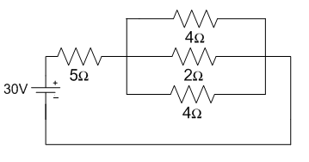 | L2 & L3
2. | State and explain Kirchhoff’s laws and determine the current in all resistors in the below circuit using Kirchhoff’s current law.  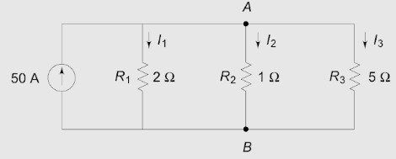 | L2 & L3
3. | State superposition theorem and determine the current passing through 3 ohm resistor using superposition theorem.  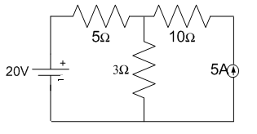 | L2 & L3
4. | Determine the average value and rms value of the waveform shown in the fig.  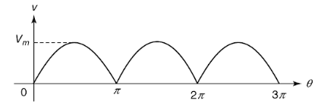 | L2 & L3
5. | Illustrate the principle of operation and construction of DC motor with a neat diagram. | L2
6. | Describe the principle of operation and the various parts of 3-phase alternator with the help of neat sketches. | L2
7. | What is the Wheatstone Bridge principle? And explain the construction of Wheatstone bridge. | L2
8. | Illustrate the working of a wind Power plant and the various parts in layout with the help of neat sketches. | L2
9. | Explain various personal safety precautions to take when working with electricity? | L2
10. | Illustrate the procedure for calculating the electricity bill for domestic consumers. | L2

Dr. B. Pangedaiah | Dr. B. Pangedaiah | Dr. G. Nageswararao | Dr. J.Sivavara Prasad
Course Instructor | Course Coordinator | Module Coordinator | Head of the Department

